Request for Proposals

Solicitation Name and Number | Construction Contractor Services for the TVHS One Five Nine Apartment Renovations Project
Responses Must Arrive No Later Than | 3:00 p.m. on September 7, 2023 (as TVHS’s clocks indicate)
Deliver Responses to | Email to: jgreen@tvhstn.org (It is the proposer’s responsibility to ensure that all responses are received)
Electronic Copies | Proposers are to use the MS Word version posted on TVHS’s website (or other electronic means) to provide a typed response. The final proposal is to be submitted in pdf format.
Solicitation Meeting | ☒ Yes ☐ No
Solicitation Meeting is Mandatory | ☐ Yes ☒ No ☐ Not Applicable
Solicitation Meeting Date and Time | August 17, 2023 at 10:00 a.m.
Solicitation Meeting Location | TVHS will host an in person meeting located at 815 Tulip Street Morristown, TN 37814.
Questions About This Solicitation | Submit questions to jgreen@tvhstn.org. by 4:00 p.m. on August 24, 2023.  TVHS will not accept questions via telephone.
Award Results | Proposers will be notified by mail and TVHS posts the award decision to its web page at: https://www.tvhstn.org/About/Procurement/Bids-Solicitations
Open Records/Public Access to Documents | All document provided to TVHS are subject to the Tennessee Open Meetings Act (TCA 8-44-101) and open records requirements.
Check TVHS’s webpage https://www.tvhstn.org/About/Procurement/Bids-Solicitations) for addenda and changes before submitting your response

General Information

1. Definitions

a. “Supplier” is inclusive of various words describing interested parties often called “vendor,” “bidders,” “contractors” and “proposers.”

2. Background and Intent of Solicitation
a. Tennessee Valley Housing Services (TVHS) is the public housing Authority located in Morristown, Tennessee. TVHS' public housing property portfolio includes nine housing properties with 6 72 dwelling units. TVHS also oversees approximately 432 Section 8 Vouchers & four (4) market safe units.

b. TVHS is soliciting proposals from qualified construction companies who desire to function as the Construction Contractor for the One Five Nine Apartments Renovation Project in Morristown, TN(Project). For this purpose, TVHS is soliciting proposals from construction firms with recent, comparable experience as a Construction General Contractor (“Contractor”), working under a guaranteed maximum price (GMP), and that are skilled in the renovation of multifamily developments with a similar size and complexity.

c. This project consists of a preconstruction phase and a construction phase with separate notices to proceed for each phase. During the preconstruction phase, the Contractor will collaborate with the project team on the design, constructability, cost and schedule of the project, and develop a Guaranteed Maximum Price (GMP) proposal to construct the project. Upon TVHS’s acceptance of the GMP, TVHS will issue a contract to the Contractor for the construction phase without additional public competition. If TVHS and the Contractor do not agree upon a GMP, TVHS will not award the construction phase of the project and will instead issuance another solicitation for that phase. See paragraph 18 of this document for more details on Scope of Work.

d. The Contractor shall be incorporated within the project team, which shall consist of TVHS, MBI Companies (the “Architects”), and other consultants as TVHS may deem necessary or appropriate (“Project Team”). The Contractor shall furnish the project team with construction expertise and pricing during the design process and then procure and manage all trades during the construction.

3. One Five Nine Apartment Renovations Overview
a. The TVHS properties currently known as C. Frank Davis Homes 38-1, C. Frank Davis Homes Extension 38-5, and John Johnson Homes 38-9 include 417 units of housing, a daycare and community room building. The contemplated scope of renovation work includes upgrades to kitchens, interior finishes, ventilation systems, electrical systems, replacement of doors and windows, as well as some associated site improvements and landscaping.

b. TVHS anticipates a 3-4 month preconstruction phase and a construction start date in the early second quarter of 2024.

c. For the purposes of this RFP, TVHS is anticipating a Construction Cost range of $10,000,000 to $12,000,000.
4. Bonds
The Contractor will provide both Payment and Performance bonds, each equal to 100% of the construction project’s cost. Documentation of bonds shall be in a format acceptable to TVHS.

5. Changes after Award
It is possible that after award TVHS will need to revise the service needs or requirements specified in this document. TVHS reserves the right to make such changes after consultation with the supplier. Should additional costs arise, the supplier must document increased costs. TVHS reserves the right to accept and negotiate these charges.

6. Codes and Ordinances
All work covered by these award documents is to be done in full accord with national, state and local codes, ordinances and orders that are in effect at the time the work is performed.

7. Contact Policy
Only contact TVHS’s Procurement Division about this solicitation from the issuance of this RFP until its award. Information obtained by any other person will not affect the risks or obligations assumed by the supplier or relieve the supplier from fulfilling any of the conditions of the resulting award. Such contact can disqualify the supplier from the solicitation process.

8. Contract Sample
TVHS will use the AIA A104 Standard Abbreviated Form of Agreement Between Owner and Contractor as modified for the contract.

9. Employees
Supplier(s) will:

a. Allow only personnel thoroughly trained and skilled to work on the job. Employees are not to be accompanied in their work area by acquaintances, family members, assistants or any person unless said person is an authorized employee of the supplier.

b. Have sufficient personnel to complete the work in a timely manner.

c. Provide adequate supervision and adequate discipline among his/her employees.

d. Provide at least one employee on every job assignment with the ability to speak, read, write and understand English so TVHS’s staff can communicate effectively with them.

e. Employ the quantity and quality of supervision necessary for both effective and efficient management at all times.

f. Ensure that employees have proper identification displayed while on the job site. Employees must wear a company uniform or have photo identification badges at all times.

g. Employees parking vehicles (whether corporately or privately owned) must ensure that company identification is on the vehicles. This may be by placards on the vehicle’s side, laminated paper with the company name placed on the dashboard or other means.

10. Evaluation
a. TVHS alone determines the supplier’s “responsive” and “responsible” status prior to award. Responsible means a business with the financial, technical, relevant experience and capacity to perform the requirements of the solicitation and subsequent contract. A responsive proposal is one that fully conforms in all material respects to the solicitation document and all of its requirements, including all form and substance.

b. TVHS will review all proposals and reserves the right to request additional necessary information, modifications, waive minor technicalities, reject all proposals, reject any proposal that does not meet mandatory requirement(s) or cancel this RFP, according to TVHS’s best interests. TVHS further reserves the right to make adjustments to its evaluation scenario if they are in TVHS’s best interest and consistent with good business practices.

c. TVHS may require oral presentations as part of the evaluation process.

d. TVHS reserves the right to ordinally rank proposals as a first step and then only detail score the top tier of proposals if determined to be in TVHS’s best interest.

e. TVHS plans to award to the best overall proposal on the following evaluation scale:

Factors | Maximum Points
Construction Manager's Experience  Similar projects  Multiple Phase Construction  Construction Management At-Risk  References | 30
Resources  Key Personnel  Current Workload  Consultants | 20
Technical Approach  Estimating  Cost Control  Schedule Control  Quality Control  Communication  Small businesses (and MBE, WBE, VBE) inclusion plan | 20
Cost of Services  Fees | 30
Total | 100
11. General Instructions
The General Instructions to Suppliers is Document D of this Solicitation.

12. Licenses
a. The supplier shall maintain all licenses necessary to conduct business in the Hamblen County and the City of Morristown.

b. The supplier must comply with all of the provisions of the Contractors Licensing Act of 1976 of the State of Tennessee, the same being set out in Tennessee Code Annotated, 62-6-101 et seq., and Section 62-6-119 as amended by 1997 Tennessee Public Act No. 153. Said Act and amendments are incorporated herein by reference.

The Executive Director of the State of Tennessee Contractor Licensing Board opined that the contractor must hold a commercial license classification (BC or BC-B) with an unlimited monetary limit. Provide a copy of the license with your submittal.

c. Subcontractor's performing the electrical, geothermal, HVAC, plumbing must be licensed when their total portion is $25,000 or more. Masonry subcontractors must be licensed when their portion equals or exceeds $100,000. Note that these subcontractor limits are reflective of total cost including materials and labor. Subcontractor licenses do not have to be provided with your submittal but at the time subcontractors are selected.

d. All specific licensure requirements of the Tennessee Department of Environment and Conservations (TDEC) must be compiled with.

e. Failure to include the required licensure information may result in an offer being deemed nonresponsive.

Scope of Work

13. Scope of Contractor’s Work
a. During the preconstruction phase, the Contractor will provide the TVHS and the Project Team with construction expertise and experience that will assist in project decision making and ensure that procedures are implemented to aggressively manage the construction costs and project schedule. During the construction phase, the Contractor will manage and administer the project construction to achieve construction completion within the contract time and budget and with high quality workmanship. TVHS seeks the Contractor who can best provide the services needed to achieve these goals.

b. Preconstruction Phase Scope
Consultation is required with the Project Team during the design phase of the project until such time that a Guaranteed Maximum Price (“GMP”) for construction is accepted. The Contractor will provide pre-construction services including but not limited to:
1. Consult with, advise, assist and provide recommendations to the Project Team on all aspects of the design of the project, including early verification of budget and schedule.

2. Provide information, estimates and alternative schemes, and participate in decisions regarding existing conditions, site utilization and construction phasing.

3. Develop information and participate in decisions regarding value engineering. Provide information on construction materials, methods, systems, phasing and costs to assist in determinations that are aimed at providing the highest quality facility within the budget.

4. Provide input to the Project Team regarding current construction industry practices, labor market and materials availability.

5. Review in-progress design documents and provide input and advice with respect to construction feasibility, construction sequencing, site utilization, alternative materials/methods and long-lead material procurements.

6. Review design documents in progress and suggest modifications to improve completeness or clarity and constructability.

7. Recommend division of the work to facilitate bidding and award of trade contracts considering such factors as minimizing disruption of existing facilities, improving or accelerating construction completion, minimizing trade jurisdiction disputes, increasing minority-owned business participation and other related issues.

8. Develop and continuously monitor the project schedule and recommend adjustments in the design documents or construction bid package to ensure completion of the project in the most expeditious manner possible.

9. Assist in cost management, including the preparation of construction cost estimates for the project throughout each design phase of the work.

10. Develop with the Project Team a continuing list of additive and deductive cost items, prioritized by TVHS, to be considered as needed to remain within the budget.

11. Develop a GMP for owner review.

c. Construction Phase Scope
The Contractor’s duties include construction of the project in accordance with all construction documents, including but not limited to:

1. Solicit and select subcontractors and material suppliers in accordance with TVHS’s desire for the inclusion of small businesses as well as minority, woman and veteran owned businesses and the Contractor’s contract.

2. Maintain a qualified, full-time superintendent with necessary staff at the job site to coordinate and provide direction of the work, as well as to provide quality assurance/quality control.

3. Work with the Project Team to establish and implement procedures for expediting and processing all shop drawings and other submittal documents. The Contractor is responsible for initial review and verification of all shop drawings to ensure they comply with the intent of the Construction Documents and are in fact ready for the Architect’s review and approval.

4. Prepare and maintain a detailed Critical Path Schedule for monitoring project progress and managing the work. Keep the Project Team fully advised on work progress status. This will include a “look-ahead” or “near-term” schedule to be provided at project meetings. If progress falls behind, the contractor will provide a recovery schedule.

5. Make available all cost and budget estimates, including supporting materials and records, to the Project Team. Provide monthly reports of actual costs and work progress as compared to estimated cost projections and scheduled work progress. Explain significant variations and provide information as requested by the Project Team.

6. Assist TVHS to communicate effectively with potential residents, adjacent property owners and the community at large.

7. Establish an effective Quality Assurance/Quality Control Plan for all construction and inspect the work as it is being performed to assure that materials furnished, and quality of work performed is in accordance with the Construction Documents.

8. Prepare Requests for Information (RFIs) when clarification of documents are required.

9. Establish effective programs for job-site safety and for maintaining current job-site records, labor relations and minority participation.

10. Prepare and distribute weekly and monthly progress reports.

11. Provide continuous change order review and processing services.

12. Manage and administer subcontractors and/or material suppliers in accordance with the terms of their contracts.

13. Schedule and conduct job meetings to ensure orderly progress of the work. Prepare and distribute a record of the meeting to the Project Team and other interested parties within three business days of each meeting.

14. Resolve, with TVHS’s approval, disputes that may arise between subcontractors and/or material suppliers as a result of the construction.

15. Comply with Davis Bacon requirements in force at the time and as applicable.

16. As construction is completed, the Contractor shall provide the following close-out services:
  - Coordinate and expedite the submittal of record documents.
  - Organize and index three operations and maintenance manuals (including warranties). Provide electronic and paper copies.

  - Acquire all necessary or required permits, including Certificate of Occupancy.

  - Start up, testing and documentation of buildings systems.

  - Prepare a project completion report for assistance in turnover of the facilities to TVHS.

  - Prepare final report of all construction costs. Assist with TVHS’s audit of final cost report and all supporting documentation. Provide lien waivers from all subcontractors and material suppliers.

d. Post-Construction Services
  - Provide prompt satisfaction of all warranty items reported by TVHS.
  - Participate in a joint inspection of the facility, with the Project Team at the end of the one-year basic warranty period, and satisfy any warranty items identified at that time.

14. Contingency
The stated contingency within the GMP will be determined based on the progress of the design at the time the GMP is determined and will be agreed upon by both TVHS and supplier. Any unused contingency at the completion of the project will be returned to TVHS.

15. Submittal Instructions
Submit your information in the order indicated below:
Document Number | Title
Solicitation Document A | General Response Section
Solicitation Document B | Affidavits
Solicitation Document C | General Instructions to Suppliers
Solicitation Document D | HUF Form 5369A
Solicitation Document E | Introduction
Solicitation Document F | Contractor’s Experience
Solicitation Document G | Resources
Solicitation Document H | Technical Approach
Solicitation Document I | Cost of Services

a. Place your company’s name on each page and number all pages consecutively.

b. The use of tables in presenting information facilitates the evaluation team’s review.

c. Do not use phrases such as “See the attached” or “Will be provided upon award.”

d. Proposals are limited to 30 pages’ total. A page is the front and reverse of one 8.5 x 11 sheet of paper.

This and the Previous Pages Do Not Need to be Returned

Construction Contractor Services for TVHS One Five Nine Apartments Renovations Project

Solicitation Document A: General Response Section

General Information about the Supplier
Sign Your Name to the Right of the Arrow
Your signature indicates you read and agree to “HUD form 5369A “Instructions to Bidders for Contracts” and that you are authorized to bind the supplier or are submitting the response on behalf of and at the direction of the suppliers’ representative authorized to contractually bind the supplier. I represent that the supplier or its applicable representative(s) has reviewed the information contained in this Solicitation Package and that the information submitted is accurate.
Printed Name and Title
Company Name
Street Address
City/State/Zip
Contact Person (Please Print Clearly)
Telephone Number
Cell Number
Supplier’s E-Mail Address (Please Print Clearly)
Addenda
Addenda are at www.tvhstn.org. Click on “About>Procurement>Bids & Solicitations” to find addenda. Please check for addenda prior to submitting a proposal.
Acknowledge addenda have been issued by checking below as appropriate:
None ☐ | Addendum 1 ☐ |  | Addendum 2 ☐ |  | Addendum 3 ☐ |  | Addendum 4 ☐ | Addendum 5 ☐
Statistical Information (Check all the apply)
This business is at least 51% owned and operated by a woman |  |  |  |  |  |  |  | Yes ☐ No ☐
This business qualifies as a small business by the State of Tennessee  Total gross receipts of not more than $10,000,000 average over a three-year period OR employs no more than 99 persons on a full-time basis |  |  |  |  |  |  |  | Yes ☐ No ☐
This business qualifies as Section 3 business (as defined by HUD):  It is at least 51% owned by a Public Housing resident or it employs Section 3 residents for at least 30% of its employee base; or it commits to subcontract at least 25% of the project’s dollars to a Section 3 business. |  |  |  |  |  |  |  | Yes ☐ No ☐
This business is owned & operated by persons at least 51% of the following ethnic background:
Asian/Pacific ☐ | Black ☐ | Hasidic Jew ☐ |  | Hispanic ☐ |  | Native Americans ☐ |  | White ☐
Prompt Payment Discount
A prompt payment discount of ________% is offered for payment within ____ days of submission of an accurate and proper invoice.

Construction Contractor Services for TVHS One Five Nine Apartments Renovations Project

Solicitation Document B: Affidavits

Conflict of Interest
1. No commissioner or officer of TVHS or other person whose duty it is to vote for, let out, overlook or in any manner superintend any of the work for TVHS has a direct interest in the award or the supplier providing goods or services.

2. No employee, officer or agent of the grantee or sub-grantee will participate in selection, or in the award or administration of an award supported by Federal funds if a conflict of interest, real or apparent, would be involved. Such a conflict would arise when the employee, officer or agent, any member of his immediate family, his or her partner, or an organization, which employs, or is about to employ, any of the above, has a financial or other interest in the supplier selected for award.

3. The grantee's or sub-grantee's officers, employees or agents will neither solicit nor accept gratuities, favors or anything of monetary value from suppliers, potential suppliers or parties to sub-agreements.

4. By submission of this form, the supplier is certifying that no conflicts of interest exist.

Drug Free Workplace Requirements
5. Private employers with five or more employees desiring to contract for construction services attest that they have a drug free workplace program in effect in accordance with TCA 50-9-112.

Eligibility
6. The supplier is eligible for employment on public contracts because no convictions or guilty pleas or pleas of nolo contender to violations of the Sherman Anti-Trust Act, mail fraud or state criminal violations with an award from the State of Tennessee or any political subdivision thereof have occurred.

General
7. Supplier fully understands the preparation and contents of the attached offer and of all pertinent circumstances respecting such offer.

8. Such offer is genuine and is not a sham offer.

Iran Divestment Act
9. Concerning the Iran Divestment Act (TCA 12-12-101 et seq.), by submission of this bid/quote/proposal, each supplier and each person signing on behalf of any supplier certifies, and in the case of a joint bid/quote/proposal, each party thereto certifies as to its own organization, under penalty of perjury, that to the best of its knowledge and belief that each supplier is not on the list created pursuant to § 12-12-106.

Construction Contractor Services for TVHS One Five Nine Apartments Renovations Project

Solicitation Document B: Affidavits - continued

Non-Collusion
10. Neither the said supplier nor any of its officers, partners, owners, agents, representatives, employees or parties interest, including this affiant, has in any way colluded conspired, connived or agreed, directly or indirectly, with any other responder, supplier, or person to submit a collusive or sham offer in connection with the award or agreement for which the attached offer has been submitted or to refrain from making an offer in connection with such award or agreement, or collusion or communication or conference with any other supplier, or, to fix any overhead, profit, or cost element of the offer price or the offer price of any other supplier, or to secure through any collusion, conspiracy, connivance, or unlawful agreement any advantage against TVHS or any person interested in the proposed award or agreement.

11. The price or prices quoted in the attached offer are fair, proper and not tainted by any collusion, conspiracy, connivance, or unlawful agreement on the part of the supplier or any of its agents, representatives, owners, employees, or parties in interest, including this affiant.

Accuracy of Electronic Copies
12. If the supplier provides electronic copies of the bid/proposal/quote to TVHS, the supplier certifies that the information provided on paper and in the electronic format is identical unless specifically noted otherwise.
No Contact/No Advocacy Affidavit
13. After this solicitation is issued, any contact initiated by any proposer with any TVHS representative concerning this proposal is strictly prohibited-except for communication with the Procurement Division. My signature signifies that no unauthorized contact occurred.

14. To ensure the integrity of the review and evaluation process, respondents to this solicitation nor any firm representing them, may not lobby or advocate to TVHS staff or Board members. My signature signifies that no unauthorized advocacy occurred.

The undersigned hereby acknowledges receipt of these affidavits and certifies that the submittal in response to this solicitation is in full compliance with the listed requirements.

Signed by
Printed Name
Title
Subscribed and sworn to before me this date
By (Notary Public)
My Commission Expires on
Notary Stamp

Construction Contractor Services for TVHS One Five Nine Apartments Renovations Project
Solicitation Document C: General Instructions to Suppliers

The following terms, conditions and instructions apply to all Tennessee Valley Housing Services (TVHS) solicitations whether they are quotations, bids, proposals, requests for qualifications or other types of solicitations unless excluded within a specific solicitation. The term “supplier” means bidder, vendor, proposer, quoter, contractor and all other terms implying or meaning one who is responding to an opportunity with TVHS. The submission of a response means that the supplier understands and agrees with TVHS’s “General Instructions to Suppliers.” Suppliers will clearly note any variance on the submittal document. TVHS will be the sole judge as to whether the variance is “material” or “immaterial” to the bid.

- Acceptance
Suppliers shall hold their price firm and subject to acceptance by TVHS for ninety calendar days from the opening date unless otherwise directed by TVHS.

- Additional Services
Upon award, while the successful supplier may inform TVHS of additional services they can provide, to add those services to the award, requires approval from the Procurement Division.

- Alterations or Amendments
Alterations, amendments, changes, modifications or additions to the purchase order or award shall not be binding without TVHS’s prior written approval.

- Anti‐Lobbying Amendment
Suppliers who submit bids and proposals must sign TVHS’s anti‐lobbying affidavit (in the solicitation document). Additionally, suppliers shall require each subcontractor and each lower‐tier subcontractor exceeding $100,000 to certify to the tier above that it will not and has not used federally appropriated funds to pay any person or organization for influencing or attempting to influence an officer or employee of any agency, a member of Congress, officer or employee of Congress, or an employee of a member of Congress in connection with obtaining any Federal contract, grant or any other award covered by 31 U.S.C. 1352. Each tier shall also disclose the name of any registrant under the Lobbying Disclosure Act of 1995 who has made lobbying contacts on its behalf with non‐Federal funds with respect to that Federal contract, grant or award covered by 31 U.S.C. 1352. Such disclosures are forwarded from tier to tier up to the Contractor to be submitted to the Port.

- Appropriation
In the event TVHS’s Board does not appropriate funds for the goods and/or services or insufficient funds exist to purchase the goods and/or services, awards and/or contracts shall terminate upon the expenditure of previously appropriated funds with no further obligations owed to or by either party.

- Assignment/Subcontracting
Supplier shall not assign the agreement, its obligations or rights hereunder to any party, company, partnership, incorporation or person without TVHS’s prior written specific consent. Any such assignment or any interest or any money due or to become due without TVHS’s prior written consent shall be void.

- Award/ Rejection of Responses
  - TVHS awards to the highest rated, responsible supplier and in TVHS’s best interest. TVHS reserves the right to reject all responses and to waive any informality in the responses received whenever TVHS determines that such rejection or waiver is in TVHS's best interest.

  - TVHS reserves the right to reject responses from any supplier who has previously failed to perform properly or to complete work or contracts of a similar nature on time; who is not able to perform the work; or who has habitually and without just cause neglected the payment of bills or otherwise disregarded his obligations to other suppliers, subcontractors and/or employees.

  - TVHS will check all respondents against State of Tennessee and federal debarment databases. Any listing on these showing an active debarment is sufficient grounds for TVHS to reject the offer from the supplier.

- Award Results
As soon as practicable after evaluation, TVHS will post the award decision and the proposal tabulation to its web page. TVHS does not typically provide individual notices to suppliers.

- Background Checks and Drug Screening
Suppliers providing services at TVHS sites must perform background checks, including drug screening, for all new employees who may be assigned to perform work at TVHS sites. Additionally, the supplier will maintain an adequate continual education program concerning harassment, drug free workplace and related topics.

- Bid Withdrawal
A supplier may withdraw or amend a solicitation response before the date and time set for receipt of bids without stating a reason. Suppliers cannot amend a bid after the bid opening unless the amendment does not materially affect the price, quality, quantity or delivery of the good or service. After the bid opening, TVHS must give approval for bid amendment or withdrawal. If granted, withdrawal after the due date is non‐reversible. The supplier must submit clear proof of a clerical error for TVHS to approve withdrawals or amendments. Amendments and withdrawals are subject to TVHS’s discretion. Bid withdrawal may affect your bid bond (if applicable).

- Books and Records
  - The supplier shall maintain all books, documents, accounting records and other evidence pertaining to the goods and services provided under an agreement and/or contract and make such materials available at its offices at all reasonable times during the contract period and for three years (and as required by federal law and/or regulations) from the date of the final payment under an agreement or contract.

  - This shall be for inspection by TVHS or any other governmental entity or agency participating in the funding of an agreement or contract, or any authorized agents thereof. Upon request, the supplier shall furnish copies of said records. Such records shall include those books, documents, payroll and accounting records that represent the supplier's costs of manufacturing, acquiring or delivering the products and services governed by an agreement or contract.

- Clean Air Act (42 U.S.C. 7401‐7671q.) and the Federal Water Pollution Control Act (33 U.S.C. 1251‐ 1387), as amended, applies to contracts of $150,000 or more. The supplier will comply with all applicable standards, orders or regulations issued pursuant to the Clean Air Act (42 U.S.C. 7401‐ 7671q) and the Federal Water Pollution Control Act as amended (33 U.S.C. 1251‐1387). Violations must be reported to the Federal awarding agency and the Regional Office of the Environmental Protection Agency (EPA). All contracts must comply with the mandatory standards and policies relating to energy efficiency which are contained in the state energy conservation plan issued in compliance with the Energy Policy and Conservation Act (42 U.S.C. 6201).

- Contract Work Hours and Safety Standards Act
  - Overtime Requirements: No supplier or subcontractor contracting for any part of the work which may require or involve the employment of laborers or mechanics shall require or permit any such laborer or mechanic in any workweek in which he or she is employed on such work to work in excess of forty hours unless such laborer or mechanic receives compensation at a rate not less than one and one‐half times the basic rate of pay for all hours worked in excess of forty hours in such workweek.

  - Violation; Liability for Unpaid Wages; Liquidated Damages: In the event of any violation of the clause set forth in paragraph (A) of this provision, the supplier and any subcontractor responsible therefore shall be liable for the unpaid wages. In addition, such supplier and subcontractor shall be liable to the United States for liquidated damages. Such liquidated damages shall be computed with respect to each individual laborer or mechanic, including watchmen and guards, employed in violation of the clause set forth in paragraph (A) of this provision, in the sum of $10 for each calendar day on which such individual was required or permitted to work in excess of the standard workweek of forty hours without payment of the overtime wages required by the clause set forth in subparagraph (A) of this provision.
  - Withholding for Unpaid Wages and Liquidated Damages: TVHS shall upon its own action or upon written request of an authorized representative of the Department of Labor withhold or cause to be withheld, from any moneys payable on account of work performed by the supplier or subcontractor under any such contract or any other federal contract with the same prime contractor, or any other federally‐assisted contract subject to the Contract Work Hours and Safety Standards Act, which is held by the same prime contractor, such sums as may be determined to be necessary to satisfy any liabilities of such Contractor or subcontractor for unpaid wages and liquidated damages as provided in the clause set forth in subparagraph (B) of this provision.

  - Compliance with OSHA: The supplier agrees to comply with section 107 of the Contract Work Hours and Safety Standards Act, 40 U.S.C. 333, and applicable Department of Labor regulations, "Safety and Health Regulations for Construction" 29 CFR 1926. Among other things, the Contractor agrees that it will not require any laborer or mechanic to work in unsanitary, hazardous or dangerous surroundings or working conditions.

  - Subcontracts: The supplier or subcontractor shall insert in any subcontracts the paragraphs set forth in this provision, Contract Work Hours and Safety Standards Act, and a clause requiring the subcontractors to include these clauses in any lower tier subcontracts. The supplier is responsible for compliance by any subcontractor or lower tier subcontractor with the clauses set forth in this provision.

The term "subcontract" under this section is considered to refer to a person who agrees to perform any part of the labor or material requirements of a contract for construction, alteration or repair. A person who undertakes to perform a portion of a contract involving the furnishing of supplies or materials will be considered a "subcontractor" under this provision if the work in question involves the performance of construction work and is to be performed (1) directly on or near the construction site, or (2) by the employer for the specific project on a customized basis. Thus, a supplier of materials, which will become an integral part of the construction is a "subcontractor" if the supplier fabricates or assembles the goods or materials in question specifically for the construction project and the work involved may be said to be construction activity.

If the goods or materials in question are ordinarily sold to other customers from regular inventory, the supplier is not a "subcontractor." The requirements of this section do not apply to contracts or subcontracts for the purchase of supplies or materials or articles normally available on the open market.

- Compliance with All Laws
Supplier agrees to comply with all federal, state and local laws, statutes, ordinances and regulations in any manner affecting the provision of goods and/or services, and all instructions and prohibitive orders issued regarding the work and shall obtain all necessary permits.

- Confidentiality of Data, Property Rights in Products and Copyright Prohibition
The supplier agrees that all information, data, findings, recommendations, bids, et cetera by whatever name described and in whatever form secured, developed, written or produced by the supplier in furtherance of this contract shall be TVHS’s property. The supplier shall take such action as is necessary under the law to preserve TVHS’s property rights while such property is within the control and/or custody of the supplier. The supplier specifically waives and/or releases to TVHS any cognizable property right of the supplier to copyright, license, patent or otherwise use of such information, data, findings, recommendations, responses, et cetera.

The supplier understands and agrees that data, materials and information disclosed to the supplier may contain confidential and protected data. Therefore, the supplier promises and assures to not disclose or discuss TVHS’s data, material and information gathered, based upon or disclosed to the supplier for this contract, without TVHS’s prior written consent.

- Contact Policy
  - From the issuance of a solicitation until an award, the supplier shall not contact anyone other than the TVHS Procurement Division about the solicitation except as directed by Procurement Division staff.

  - Information obtained from anyone other than the TVHS Procurement Division shall not affect the risks or obligations assumed by the supplier or relieve the supplier from fulfilling any of the conditions of the agreement and/or contract for a project. Such unauthorized contact can disqualify the supplier from participation in the solicitation process.

  - Suppliers must submit all questions pertaining to the bid and/or bid documents via email to the Procurement Division at jgreen@TVHStn.org.

- Contracts
  - TVHS posts a sample contract and contract rider to its web page for potential suppliers to review. While these are sample documents, actual contracts and riders will be similar in format. By responding to a solicitation, suppliers certify they have reviewed the sample contract and rider and are comfortable signing a similarly formatted contract in the event they receive the award. If there are questions about the contract form and requirements, the suppliers must raise questions during the solicitation process.

  - If TVHS must sign the supplier’s contract document, note:
    - TVHS cannot indemnify the supplier
    - TVHS cannot “hold harmless” the supplier
    - TVHS requires a copy of the proposed contract with easy‐to‐read formatting of text (i.e., no whole paragraphs in upper case). This may be provided in addition to the standard contract simply for TVHS’s ease of reading.

- Cooperative Procurement
  - TVHS may use properly bid and awarded solicitations from other governmental agencies in lieu of issuing its own solicitations‐provided such language was in the solicitation and that it is in TVHS’s best interest. Usage of cooperative contracts occurs only after TVHS’s Procurement Division has reviewed and approved the proposed cooperative contract.

  - TVHS often asks suppliers to indicate whether other governments may use the award at the same price (plus any delivery charges due to distance). In such cases, the supplier may, without harming their award, refuse to extend the terms to other governments. If the supplier extends the terms to other governments, the transactions are solely between the other government and the supplier.

- Debriefing
If requested, TVHS staff will conduct a debriefing meeting to discuss an award decision. If you are interested in such a meeting, please contact the TVHS Procurement Division.

20. Delivery
All deliveries shall be to the designated TVHS property and they must be Freight on Board (FOB) Morristown, Tennessee with all delivery, handling, surcharges and other charges included in the bid price. Failure to do so may cause rejection of the bid. TVHS typically does not pay surcharges.

- Expenses Incurred
All expenses incurred in the preparation and submission of a response to a solicitation shall be borne by the supplier.

- Failure to Enforce
Past failure to enforce a contract provision does not mean that TVHS has waived its rights to enforce said provision or any other provision.
- Federal Obligation
The federal government is not a party to TVHS’s solicitation and is not subject to any obligations or liabilities to a non‐federal entity, contractor or any other party pertaining to any matter resulting from its award.

- Federally Required Orders/Directives
Both parties agree that they will comply with the following laws and directives that TVHS has received from HUD and other branches of the federal government. These orders and/or directives shall be a part of any award and/or contract:

  - Executive Order 11061, as amended, directs the Secretary of HUD to take all action necessary and appropriate to prevent discrimination by agencies that utilize federal funds.

  - Executive Order 11246: “Equal Employment Opportunity.”

  - The Age Discrimination Act of 1975.

  - Anti‐Drug Abuse Act of 1988 (42 U.S.C. 11901 et. seq.).

  - Copeland “Anti‐Kickback” Act.

  - Domestic preferences for procurements (Federal Regulations (200.322)).
As appropriate and to the extent consistent with law, provide a preference for the purchase, acquisition or use of goods, products or materials produced in the United States (including iron, aluminum, steel, cement and other manufactured products). The requirements of this section must be included in all sub‐awards including all contracts and purchase orders for work or products. For purposes of this section: (1) ‘‘Produced in the United States’’ means, for iron and steel products, that all manufacturing processes, from the initial melting stage through the application of coatings, occurred in the United States. (2) ‘‘Manufactured products’’ means items and construction materials composed in whole or in part of nonferrous metals such as aluminum; plastics and polymer‐based products such as polyvinyl chloride pipe; aggregates such as concrete; glass, including optical fiber; and lumber.

  - Energy Policy and Conservation Act.

  - Equal opportunity clause ((41 CFR §60‐1.4(b)) prohibiting workplace discrimination and its application to both prime and subcontractors.

    - Lead Based Poisoning Prevention Act (42 U.S.C. 4821‐4846 as implemented by 24 CFR Part 35).

- The Solid Waste Disposal Act (24 CFR 85.36(1) and Section 6002)

- Public Law 88‐352, Title VI of the Civil Rights Act of 1964.

- Public Law 90‐284, Title VIII of the Civil Rights Act of 1968, popularly known as the Fair Housing Act.

The mention herein of any law, directive, statute or executive order is not an indication that such law, directive, statute or executive order is necessarily applicable. Nor is the failure to mention any statute or executive order intended as an indication that such statute or executive order is not applicable.

Therefore, each provision of law and each clause, which is required by law to be inserted in an agreement, shall be deemed to have been inserted herein, and an agreement shall be read and enforced as though such provision or clause had been physically inserted herein. If, through mistake or otherwise, any such provision is not inserted or is inserted incorrectly, the agreement and/or contract shall forthwith be physically amended to make such insertion or correction upon the application of either party.

- Governing Law
All the laws of the State of Tennessee, applicable federal laws and regulations govern TVHS purchase orders and other contracts. All obligations of the parties are performable in Hamblen County, Tennessee. The Chancery Court and/or the Circuit Court of Hamblen County, Tennessee, shall have exclusive and concurrent jurisdiction of any disputes arising hereunder.

- HUD Forms/Documents
The supplier should review the documents below for vital details about a solicitation and an award and/or contract. This reference incorporates these documents as if they are specified within the solicitation document. These documents bind suppliers when they submit a response to a solicitation and the document has relevance to the solicitation.

Go to http://portal.hud.gov/hudportal/HUD?src=/program_offices/administration/hudclips to access these documents. If you cannot find the document there or if you need assistance, contact jgreen@TVHStn.org.

HUD Form 4010 ‐ Federal Labor Standards Provisions

Applicability: Construction with Community Planning and Development Program funds HUD Form 5369 ‐ HUD’s Instructions to Suppliers for Contracts
Applicability: All solicitations
HUD Form 5369 A ‐ Representations & Certifications of Suppliers Applicability: All solicitations

- Inclement Weather/Operational Interruptions
During inclement weather, the Procurement Division operates under the following procedures concerning solicitations, closures and delays:

  - If TVHS’s CEO closes the company prior to the time set for solicitation opening, all solicitations due that day occur on the next operational business day.

  - Other weather/interruptions are at Procurement Director’s discretion.

  - TVHS is not responsible for any commercial carrier’s decision regarding deliveries during weather occurrences or any other operational interruption.

- Indemnification/Hold Harmless
Supplier shall indemnify, defend, save and hold harmless TVHS, its officers, agents and employees from all suits, claims, actions or damages of any nature brought because of, arising out of, or due to breach of the agreement by the supplier, its subcontractors, suppliers, agents or employees or due to any negligent act or occurrence or any omission or commission of supplier, its subcontractors, suppliers, agents or employees.

- Independence
The supplier shall acknowledge that it and its employees serve as independent suppliers.

- Informalities
TVHS reserves the right to waive informalities and irregularities as minor defects in a bid response or variations from the exact requirements of the solicitation provided the defects or variations do not affect the price, quality, quantity or delivery of the service.

- Inspection
The supplier is responsible for thoroughly inspecting the site of the proposed work and for becoming completely familiar with the work circumstances. The supplier’s failure to do so will not obligate TVHS to pay more for goods or service.

- Insurance
  - TVHS’s solicitation document may include specific insurance requirements. If so, the supplier will provide a Certificate of Insurance matching those requirements to TVHS. Suppliers must review the insurance requirements with their insurance agents and attest that they can provide the required insurance. TVHS’s solicitations have a “Yes/No” check box to indicate that the supplier has reviewed the requirements and can provide the insurance certificates within the specified timeline.

  - Should the certificate expire during the term of the award, the supplier is responsible for providing an updated certificate before the expiration date. TVHS will not permit suppliers to work until an acceptable certificate of insurance is in place.

- Interest of Current & Past Members, Officers or Employees
TVHS officers, employees, Board of Commissioners and other public officials having responsibilities over the awarded project shall not, during their tenure and for one year thereafter, have any interest, direct or indirect, in a contract, agreement or purchase order or the proceeds thereof.

- Interpretations
TVHS is not responsible for oral interpretations of specifications. Submit written requests for interpretation as indicated in the solicitation document. TVHS posts addenda (official changes to specifications) to its web page. It is the supplier's responsibility to examine the web page for addenda. All such addenda become part of the contract and bind suppliers to such addenda.

- Invoicing
The following guidelines apply to all TVHS awards whether they result in purchase orders or contracts. However contractual awards often have slight variations in the payment cycle. These variations are explained in the award meeting with the supplier.

  - Email invoices only to the designated contact at TVHS. Do not send invoices via USPS.

  - Until a purchase order is in place, work is not to be performed nor are goods to be delivered. TVHS does not have an obligation to pay for the work performed or goods delivered before the issuance of a purchase order.

  - Purchase orders are for a specific purchase and generally expire on June 30th or December 31st of each year. Do not continue to bill against purchase order numbers without permission.

  - While TVHS wants invoices emailed to the designated contact within 10 days following the delivery of goods or services, suppliers must submit invoices within 90 days of the delivery of goods or services. TVHS may deny invoices submitted after 90 days.

  - The purchase of goods and services for use by TVHS owned properties are exempt from Tennessee sales and use tax pursuant to Tennessee Code Annotated 67‐6‐329(a) (4). TVHS is generally exempt from the federal excise tax.

Upon the placement of a purchase order or the award of a contract, TVHS will provide a State of Tennessee Sales Tax Exemption form to the supplier. TVHS will not pay taxes on invoices for its tax‐ exempt properties. Note that the State of Tennessee does not issue sales tax exemption numbers to local governments such as TVHS.

  - Invoices must:
- Be numbered
- List a date on them that is after the work is completed or goods delivered
- List the purchase order number
- Breakdown pricing according to the award structure
- Show the Supplier’s Name
- Show the Supplier’s Address

- Morristown/Hamblen County Obligations
The City of Morristown and Hamblen County are not parties to TVHS’s solicitation and are not subject to any obligations or liabilities to a contractor or any other party pertaining to any matter resulting from its award.

- Limitation of Liability
TVHS is not liable for any indirect, incidental, consequential, special or exemplary damages or lost profits, even if TVHS has been advised of the possibility of such damages.

- Minority and Women‐Owned Businesses
TVHS desires to conduct as much business as possible with minority and women‐owned businesses. These businesses are at least 51% owned and operated by a minority or woman. TVHS also encourages its suppliers when they subcontract to utilize minority and/or women‐owned businesses.

- News Releases
As a matter of policy, TVHS does not endorse the services of suppliers. Suppliers will not make news releases concerning any resultant contract from a solicitation without TVHS’s prior written approval.

- Non‐Conforming Terms and Conditions
Should a supplier submit non‐conforming terms and conditions, TVHS reserves the right to request the supplier to withdraw non‐conforming terms and conditions that do not materially affect the price, quality and/or delivery of the goods and/or services.

- Non‐Discrimination and Non‐Conflict Statement
  - The supplier agrees not to exclude persons on the grounds of handicap, age, race, color, religion, sex or national origin from participation in, or deny benefits to, or otherwise subject to discrimination in the performance of an agreement, or in the employment practices of the supplier.

  - The supplier shall post notice of such non‐discrimination and shall post it in a conspicuous place available to all employees and applicants. The supplier covenants that it complies with the Fair Wage and Hour Laws, the National Labor Relations Act and other federal and state employment laws as applicable. The supplier covenants that it does not engage in any illegal employment practices.

  - The supplier covenants that it has no public or private interest and shall not acquire directly or indirectly any interest that would conflict in any manner with the provision of its goods or performance of its services.

  - The supplier warrants that no part of the total contract amount provided herein shall be paid directly or indirectly to any officer or employee of TVHS as wages, compensation or gifts in exchange for acting as an officer, agent, employee, subcontractor or consultant to the supplier in connection with any goods provided or work contemplated or performed relative to an agreement and/or contract.

  - Title VI of the Civil Rights Act of 1964 (42 U.S.C. § 2000d et seq.) “Nondiscrimination in Federally Assisted Programs” states “No person in the United States shall, on the grounds of race, color or national origin, be excluded from participation in, be denied the benefits of or be subjected to discrimination under any program or activity receiving federal financial assistance.”

  - Title VII of the Civil Rights Act of 1964 (42 U.S.C. § 2000d et seq.) prohibits employers from discriminating against employees based on sex, race, color, national origin and religion. It generally applies to employers with 15 or more employees, including federal, state and local governments. Title VII also applies to private and public colleges and universities, employment agencies and labor organizations.

  - TVHS’s policy requires that all its services and activities be administered in conformance with the requirements of Title VI & VII. This extends to the suppliers that TVHS awards/contracts with. Suppliers must be compliant with Title VI and VII.

- Non‐Escalation
Unless otherwise specified within the solicitation, the prices reflected in the agreement and/or contract shall remain firm with no provision for price increases during the term of the contract.

- Open and Fair Opportunities
During the term of an award, the supplier shall not create barriers to open and fair opportunities to participate in TVHS contracts or to obtain or compete for contracts and subcontracts as sources of supplies, equipment, construction and services. During the performance of an award, neither the supplier nor any party subcontracting under the authority of the award shall discriminate nor tolerate harassment based on race, color, sex, religion, nationality, creed, marital status, sexual orientation, age or the presence of any sensory, mental or physical disability in the employment or application for employment or in the administration or delivery of services or any other benefits under the award.

- Order of Precedence
Any inconsistency in solicitations or contracts shall be resolved by the following precedence order:
- The signed contract or purchase order
- The solicitation document and any addenda thereto
- Signed copy of the bid or proposal
- General conditions/instructions/information
- General Instructions to Suppliers
- Supplemental conditions (if any)
- Special conditions (if any)
- Technical specifications
- Drawings (if any)

- Payment
  - TVHS pays suppliers electronically via direct deposit (ACH).

Without this option, the supplier must log on periodically to ascertain payment status. TVHS strongly urges suppliers to set up the Vendor Portal with a generic email address as it is self‐service, and you must know the email address and password. Email addresses for specific employees are problematic if the employee leaves the organization.

  - TVHS is not able to routinely offer payment history assistance. If the supplier is unable or unwilling to use TVHS’s Supplier Portal to track payments, the supplier must consider whether to work with TVHS.

  - TVHS asks for a prompt payment discount percentage in its solicitations. Suppliers may indicate no discount or any discount they may offer.

- Program Fraud/False Statements or Related Acts
31 U.S.C. Chapter 38 (Administrative Remedies for False Claims and Statements) applies to the supplier’s actions pertaining to this solicitation and award.

- Proof of Financial and Business Capability
Suppliers shall provide, upon request, satisfactory evidence of their ability to furnish products or services in accordance with the terms and conditions of a specification. TVHS shall make the final determination as to the supplier’s ability.

- Proprietary Information
TVHS operates under Tennessee’s Open Records Act and all information in TVHS’s possession is subject to disclosure upon request. This applies whether the supplier has stamped such information as “confidential,” “proprietary” or other similar phrases.

- Protests
  - This section applies only to “formal sealed solicitations” and not to “requests for written quotes.” Requests for written quotes are not bids and protest procedures do not apply. Suppliers may protest the process or award of a solicitation for serious violations of TVHS’s procurement policy. TVHS must receive process protests at least 72 hours before its due date.

  - Award protests must be received within 5 calendar days after award (i.e., when results are posted to TVHS’s webpage), or the protest will not be considered. Protests must be in writing and submitted to the Procurement Director. The Procurement Director will forward the protest to the CEO who shall issue a written decision on the matter.

  - The CEO may suspend the procurement pending resolution of the protest if warranted by the facts presented. TVHS will advise the protestor as soon as possible in writing as to the action taken.

  - Protests shall include, as a minimum, the following information:
- Names, addresses and telephone number(s) of the protestor(s).
- The solicitation number and project title.
- A detailed statement of the basis for the protest.
- Supporting evidence or documents to substantiate any arguments.
- The form of relief requested (e.g. reconsideration of their offer).

  - Appeals
If a protestor is not satisfied with the decision of the CEO, the protestor may appeal to the TVHS Board. Such appeals shall be in writing (see above) and must be submitted within five business days after the CEO’s written decision is released. The written documentation is to include language that details how the written decision of the CEO is in error.

- Purchase Orders or Contracts are Required
TVHS requires (though there are exceptions ‐ check with the Procurement Division for details) the issuance of a purchase order or a signed contract before work commences or goods delivered. Alternatively, in emergency or quick turn‐around situations, TVHS may use credit cards for payments. If a supplier is instructed to deliver goods or services without a purchase order or contract, the supplier is to contact the Procurement Division for a decision as to whether to proceed or not.

- Recycled/Recovered Products
  - To the extent practicable and economically feasible, suppliers shall provide a competitive preference for products and services that conserve natural resources and protect the environment and are energy efficient.

  - Examples of such products may include, but are not limited to, products described in U.S. Environmental Protection Agency (U.S. EPA) guidelines at 40 C.F.R. Parts 247‐253, implementing section 6002 of the Resource Conservation and Recovery Act, as amended, 42 U.S.C. § 6962. Suppliers shall include this provision in all its subcontracts, with the requirement that it shall flow down to all subcontracts regardless of tier.

  - These efforts must be consistent with maintaining a satisfactory level of competition unless the supplier determines that such items: (1) are not reasonably available in a reasonable period of time;
(2) fail to meet reasonable performance standards, which shall be determined on the basis of the guidelines of the National Institute of Standards and Technology, if applicable to the item; or (3) are only available at an unreasonable price.

- Rejection of Responses
TVHS may reject responses from any or all suppliers if it is in its own best interest.

- Requirements Contracts
Unless otherwise specified, any requirements and/or contracts/agreements shall be an “open‐end” type of agreement and there is no guarantee that TVHS will require any specified or minimum level of products or services. TVHS plans to use the successful supplier exclusively, but TVHS reserves the right to purchase these goods/services elsewhere if it is in TVHS’s best interest.

- Restrictive or Ambiguous Specifications
It is the supplier’s responsibility to review the entire solicitation packet and to notify the Procurement Division if the specifications unnecessarily restrict competition or are conflicting or ambiguous. The Procurement Division must receive any such question, in writing, regarding the specifications or bidding procedures with enough time remaining before the opening for an addendum to be issued. Typically, such information must be supplied to Procurement at least five business days prior to the solicitation’s due date.

- Rights in Data and Patent Rights
TVHS shall have exclusive ownership of all proprietary interest in, and the right to full and exclusive possession of all information, materials and documents discovered or produced by the supplier pursuant to the terms of the agreement and/or contract, including but not limited to, reports, memoranda and/or letters concerning the research and reporting tasks of the agreement and/or contract.

- Right to Inspect
TVHS reserves the right to make inspections of service provision and/or the supply of goods.

- Royalties and Patents
  - The supplier guarantees that he has full legal rights to inventions, materials, supplies, equipment, machinery, articles, software and other items involved in the contract. The award and/or contract price shall include compensation for all royalties and costs arising from patents, trademarks and copyrights that are, in any way, involved in the award and/or contract. It is the supplier’s responsibility to pay for all such royalties and costs.

  - During the pendency of any claim against supplier or TVHS with respect to supplier's ownership and/or authority, TVHS may withhold payment of any sums otherwise owed hereunder. The supplier will hold harmless and indemnify TVHS, its employees, agents and officers for trademark, intellectual property infringement and copyright infringements that the supplier causes during performance of the work.

- Section 3 of the Housing & Urban Development Act of 1968
All contracts awarded are subject to Section 3 requirements. Supplier shall seek to fill any and all position that are needed and unfilled with residents of TVHS communities. For additional information, go to http://www.hud.gov/offices/fheo/section3/Section3.pdf. Upon award, the successful supplier will complete a Section 3 project plan for TVHS. The successful supplier will supply TVHS with job announcements for any positions that must be filled as a result of the award of TVHS work.

- Solicitation Delivery
Specific instructions for solicitation delivery are on the cover page of each solicitation. It is the supplier’s responsibility to follow those instructions. TVHS will not accept late responses (delivered after the indicated due date and time). Bids that arrive late due to the fault of U. S. Postal Service, United Parcel Service, DHL, FEDEX, any delivery/courier service, any other carrier of any sort or any electronic means are considered late and shall not be accepted. Such bids shall remain unopened and not be considered.

- Solicitation Evaluation
To verify that suppliers have adequately incorporated all elements of the work and the requirements of the solicitation documents in the bid price, the supplier shall, upon TVHS’s request, promptly make available for TVHS’s review, a complete itemization and breakdown of the total bid amount, a description of the supplier’s understanding of the work and a proposed schedule. Prior to the award, the supplier and any or all subcontractors may be required to attend a bid evaluation meeting with TVHS and the supplier shall bring any requested documentation to the meeting. In the event the supplier refuses to supply the documentation discussed in this section or refuses to attend the meeting, TVHS may reject the bid or proposal as non‐responsive.

- Subcontractors
  - The supplier may sublet portions of the work, however TVHS must approve subcontractors prior to them commencing work. Additionally, TVHS must approve changes in subcontractors used.

  - Subcontractors shall conform, in all respects, to the applicable provisions specified herein for the supplier and shall be subject to TVHS’s approval. The supplier shall not employ any subcontractor, either initially or as a substitute, against whom TVHS has a reasonable objection.

  - Subcontractors shall be under the sole direction, authority and responsibility of the supplier and the supplier shall take all steps necessary to ensure that subcontractors comply with the requirements. The work to be done by the subcontractors shall be outlined in detail by the supplier.
Supplier is responsible for all acts and omissions of their suppliers, subcontractors and others performing or furnishing any of the work directly or indirectly on behalf of the supplier.

  - Subcontractors must also:

- Not be on state or federal debarment lists.
- Carry the insurance coverages as outlined in the solicitation document.
- Comply with all Davis Bacon requirements that may apply to a project.

- Supplier Survey
TVHS, as a part of its continuous improvement program, will survey its departments, divisions, and employees about the quality of the goods and/or services provided by the successful supplier. TVHS shares the results with the supplier. If necessary, TVHS and the supplier will then jointly work on an improvement program. In extreme cases, TVHS may end contracts due to survey results.

- Unit Prices
If the bid document includes a schedule of unit prices for labor and materials or other items to establish a cost basis for unforeseen contract changes, TVHS reserves the right to reject, without impairing the balance of the bid, any or all such predetermined unit prices, and negotiate such unit prices during the term of the award.

- Use of Solicitation Forms
Suppliers are to complete the forms contained in the solicitation package. Failure to complete these forms may result in the rejection of your response. Suppliers are not to change the pricing method that is on the solicitation document unless the Procurement Division approves the change.

- Utilities
  - When work is at or in its apartments, TVHS does not supply utilities for suppliers since the residents pay their own utility bills. In such cases, the supplier will arrange for any necessary utilities.

  - When work is at its office areas, vacant apartments and other non‐resident locations, TVHS will provide utilities for suppliers if they are currently available in the area.

  - The supplier must ascertain the availability of utilities prior to submitting a bid or quote.

- Workplace Violence Prevention Policy
TVHS is committed to providing a safe, healthy and secure work environment. The presence of weapons, violence, threats of violence and other disruptive behavior in the workplace is prohibited. This policy applies to anyone on TVHS property, including but not limited to all employees, suppliers, volunteers, interns, residents, temporary employees, board members and visitors. Threats, threatening behavior or acts of violence against employees, visitors, guests or other individuals on TVHS property will not be tolerated. Any person who makes threats, exhibits threatening behavior or engages in violent acts on TVHS property shall be removed from the premises as quickly as safety permits and shall remain off TVHS premises pending the outcome of an investigation. Violation of this policy by non‐employees may result in suspension and/or termination of any business relationship, appropriate legal action or other disciplinary response deemed appropriate. TVHS may grant exceptions from this policy, at its discretion, in unusual circumstances.

Weapons include:
- Explosive devices, its component parts or an explosive weapon principally designed, made or adapted for delivering or shooting an explosive weapon.
- Firearms including machine guns, short barrel rifles, shotguns or handguns.
- Switchblade knives or any other type of knife not necessary for a work assignment.
- Brass knuckles.
- Or any other instrument for infliction of bodily injury, serious bodily injury or death which has no common lawful purpose.

The worksite includes all property owned or occupied by TVHS (including TVHS job sites) or in a TVHS vehicle.

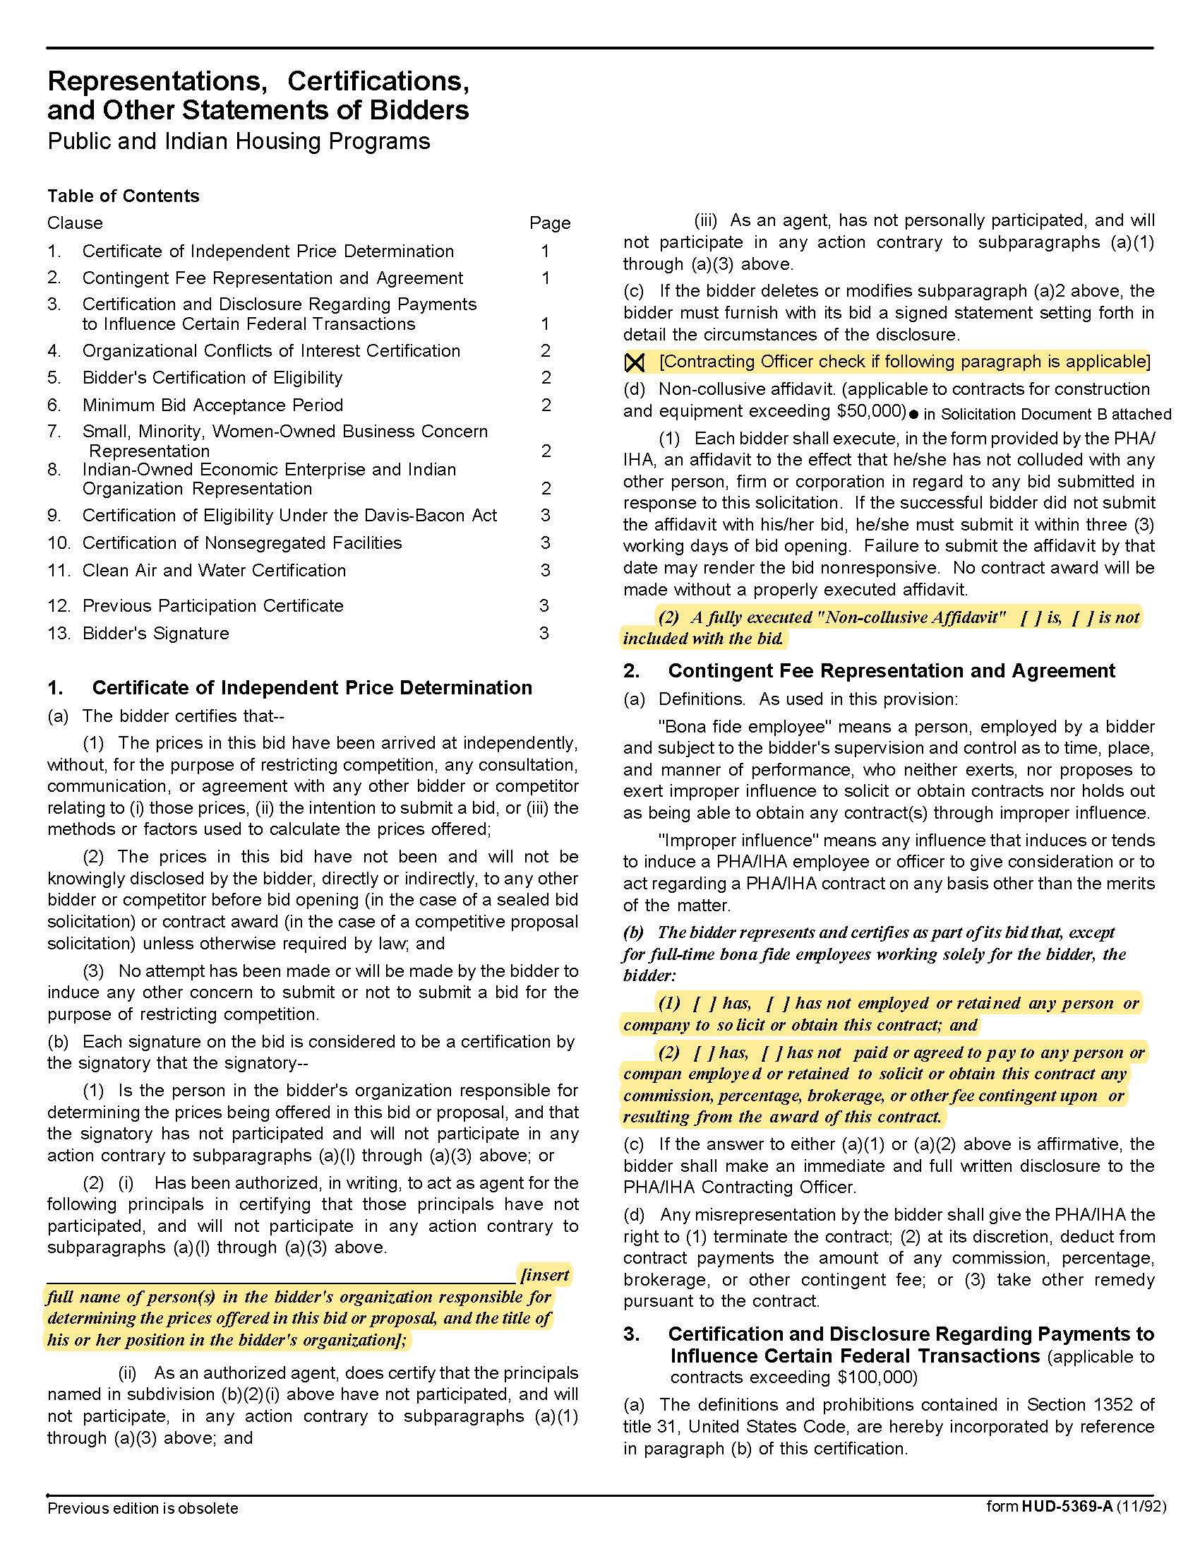

Construction Contractor Services for TVHS One Five Nine Apartments Renovations Project
Solicitation Document D: HUD Form 5369A

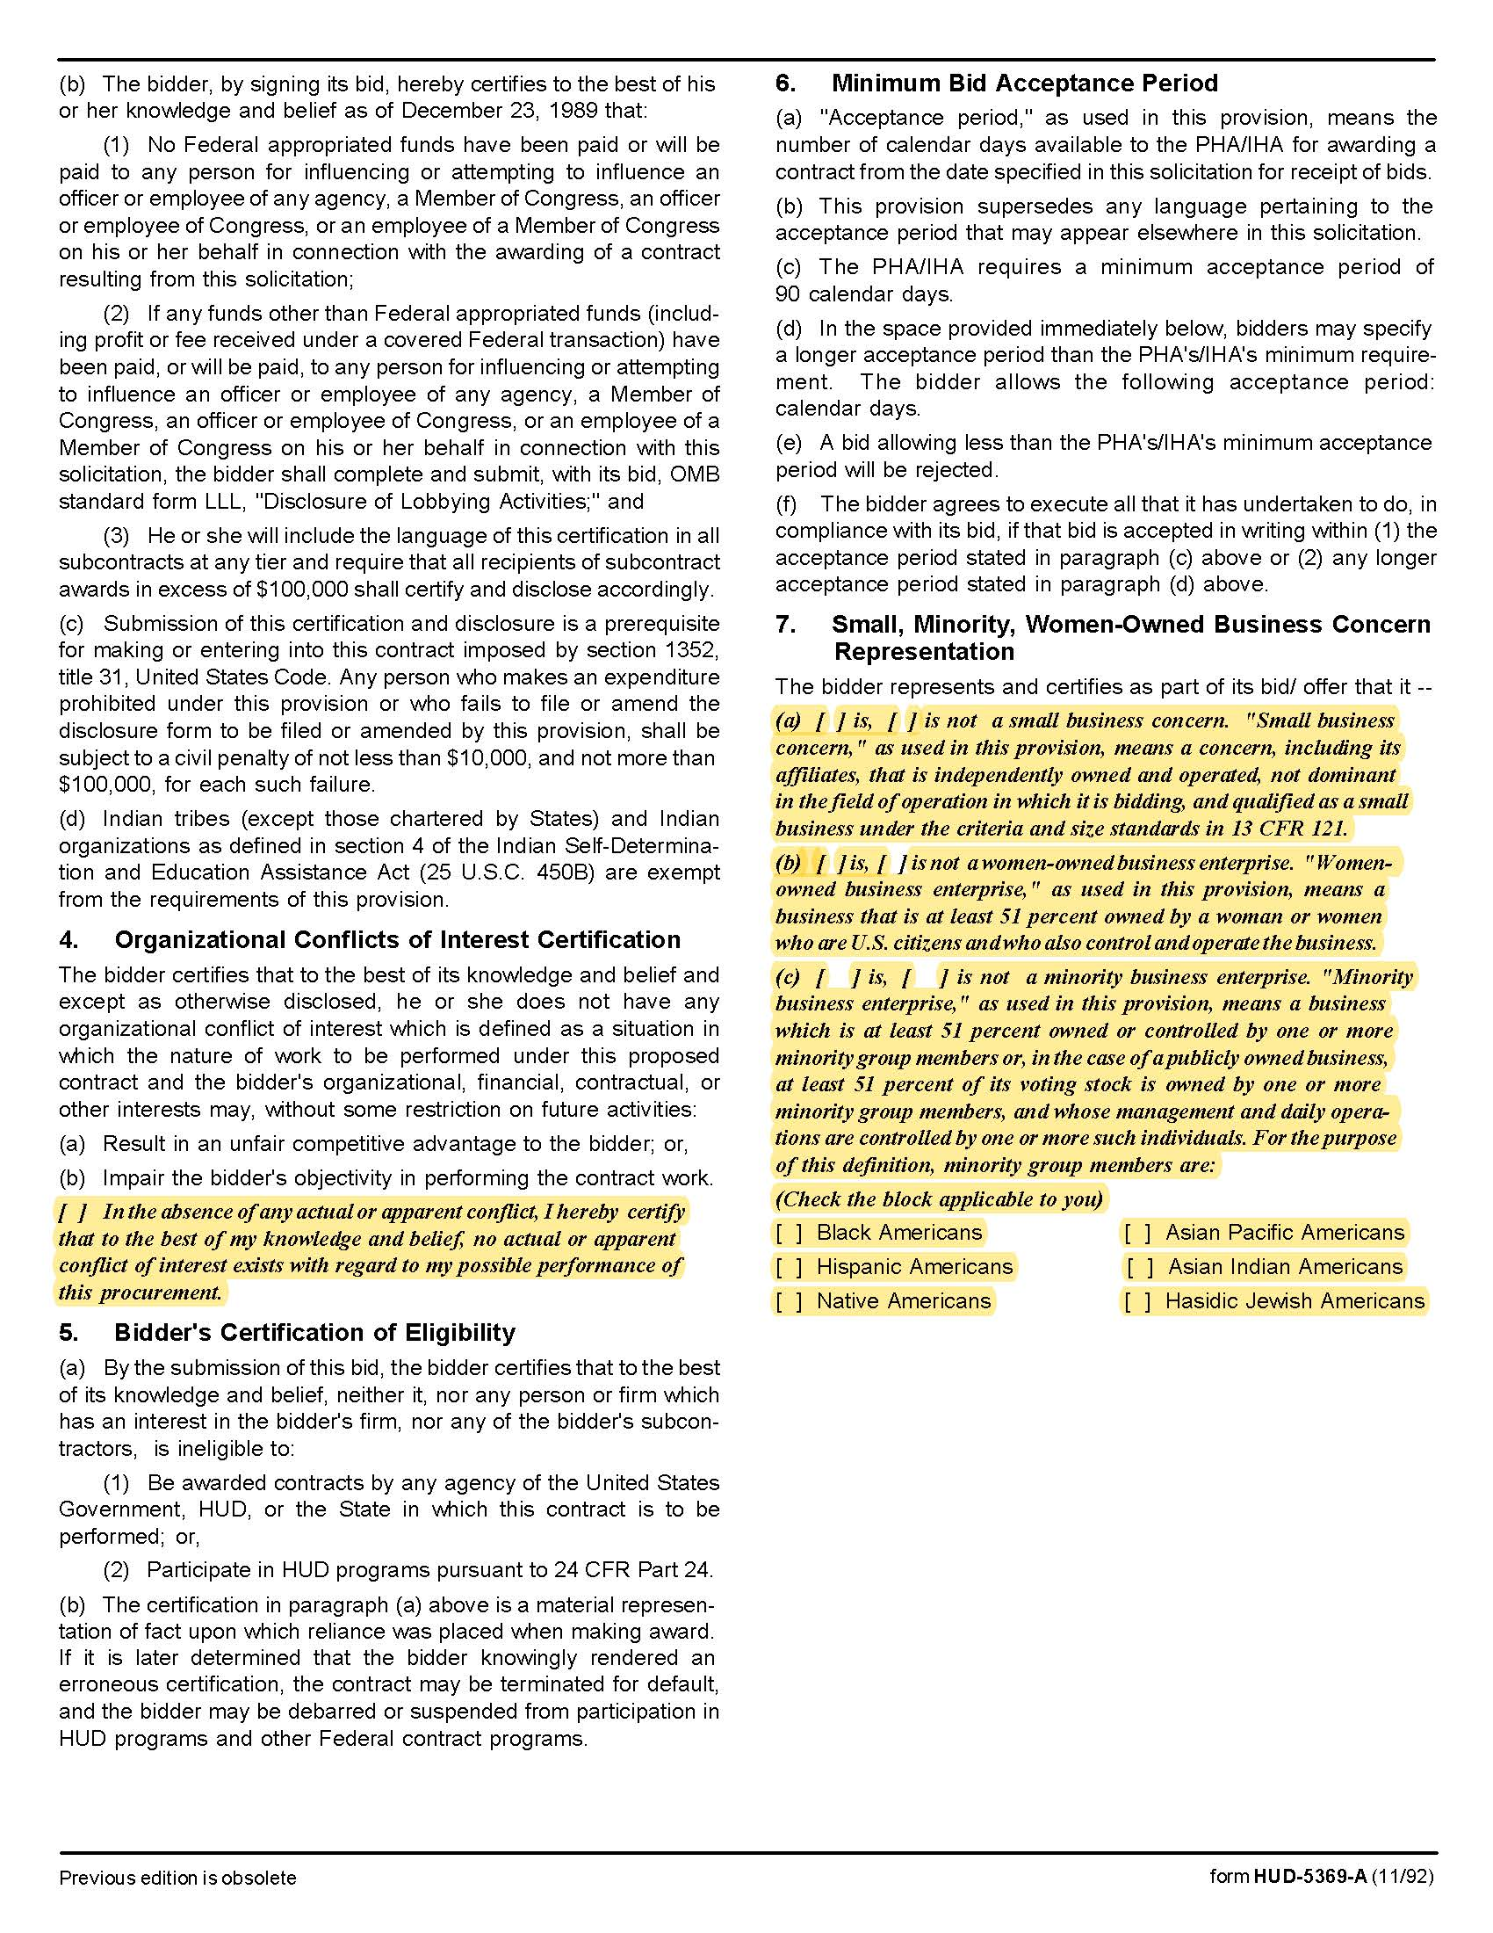

Construction Contractor Services for TVHS One Five Nine Apartments Renovations Project
Solicitation Document D: HUD Form 5369A - Continued

Construction Contractor Services for TVHS One Five Nine Apartments Renovations Project
Solicitation Document C: HUD Form 5369A - Continued
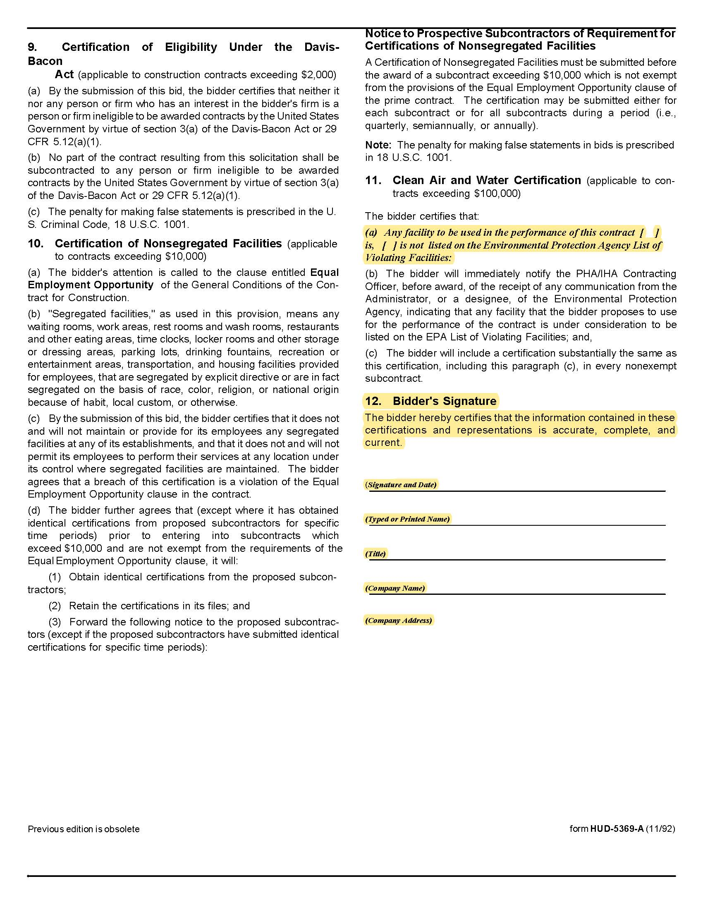

Construction Contractor Services for TVHS One Five Nine Apartments Renovations Project

Solicitation Document E: Introduction

This is a one-to-two-page introductory letter that:

- Provides a high-level introduction of your company.

- Explains the type of organization (Corporation, Partnership, Joint Venture, LLC, et cetera).

- State of Tennessee Contractor's License Number, Expiration Date, Classification and Limit.

- Details of your company’s history and expertise.

- Details why the project is of interest to you.

- Explains why TVHS should select your company.

Construction Contractor Services for TVHS One Five Nine Apartments Renovations Project
Solicitation Document F: Construction Manager’s Experience

Use this section to provide:

- Provide a summary of similar projects completed in the last five years. Specifically, highlight and
provide details (project dates, client info, budget/costs, project size, et cetera) for projects that were multifamily residential, a part of a multiphase development, and utilized the construction manager at risk delivery method.

- Please provide three references. References should include clients on one or more of the projects
highlighted in the section above.

Construction Contractor Services for TVHS One Five Nine Apartments Renovations Project
Solicitation Document G: Resources

Use this section to provide:

1. Provide an organizational chart showing the proposed structure, interrelationships and interactions of the proposed CONTRACTOR team. Describe the proposed roles and estimated involvement for the listed key personnel during pre-construction, construction, and/or throughout the project and include resumes for each. Include similar project experience for each proposed team member.

2. Your current workload (committed projects that are either in construction and pre-construction) and the respective scheduled completion dates for each project.

3. Please describe previous professional experiences or collaboration, if any, with MBI, or Partners’ Development.

Construction Contractor Services for TVHS One Five Nine Apartments Renovations Project
Solicitation Document H: Technical Approach

Use this section to provide information that explains your technical approach to the project. Include:

1. A brief description of the organization’s approach to ensure the successful development of the project. Include how your organization will fit within the Project Team and the anticipated level of involvement from different members of the project team throughout each phase.

2. Identify any components of the Scope of Work included in the RFP (see paragraph18) that the organization is unable to perform or if additional scope should be included but is not currently listed.

3. Your process for assuring the project cost is within the scope and budget and completed on time.

4. Identification of the risks you would anticipate on this type of project, and provide the countermeasures you would employ to minimize those risks.

5. Your plan to attract, retain and use small businesses plus minority, women and veteran owned subcontractors. Inclusion of these companies is very important to TVHS and the supplier must have an effective plan for attracting these companies as participants.

Construction Contractor Services for TVHS One Five Nine Apartments Renovations Project
Solicitation Document I: Cost of Services

Using the Service Fee Allocation Chart located in Appendix 1 provide information that explains your Cost of Services and supports your financial strength to provide the necessary bonding capacity. Include:

1. Cost Items Details (do not alter the structure below)

a | Provide the lump sum preconstruction fee. | $
b | Provide a proposed construction management fee including overhead and profit applicable to a project construction budget of approximately $12,000,000. | %
c | State the general conditions cost during construction (on a monthly basis). | $
d | General Liability Insurance Rate | $
e | Builders Risk Rate | $
f | Performance and Payment Bond Rate | $

2. Provide a summary of the organization’s financial capability to ensure a payment and performance bond in an amount equal to 100% of the construction cost limitation noted above.

3. A listing of current and projected bonding capacity within the next 12 months to 24 months.

4. A demonstration of your organization's safety record by providing your Experience Modification
Rating (EMR) and corresponding man-hours of work performed for the past 5 years.

Construction Contractor Services for TVHS One Five Nine Apartments Renovations Project

Appendix 1: Service Fee Allocation

 | General Conditions | CM Fee | Preconstruction | Paid By Owner
Personnel Expenses, Including
Superintendent | X
Assistant Superintendent (Indicate if required) | X
Estimator |  | X | X
Project Manager | X |  | X
Project Engineer (Indicate if required) | X
Project Assistants/Office Staff | X
Project Accounting |  | X
Project Executive |  | X | X
Monthly Photos & Reports | X
Scheduling |  | X | X
As-Builts | X
Manuals | X
Prints, Copies, etc. |  |  | X
Mileage | X
Toilets, Temporary Building | X
Cell Phone Service/Internet | X
Equipment: Cameras, Computers, Phone, Print, Copy, Fax | X
Safety Supplies (First Aid, Hard Hats, etc.) | X
Testing (Pre-specified) |  |  |  | X
Mobilization | X
Temporary Utilities |  |  |  | X
Project Signage | X
General Liability Insurance (Provide Rate) | X
Builders Risk (Provide Rate) | X
Performance & Payment Bond (Provide Rate) | X

